TERRINGTON ST CLEMENT PARISH COUNCIL 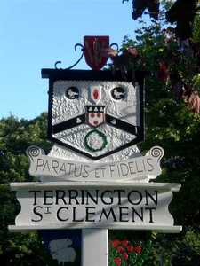

Clerk: K Treacher. Parish Office, The Pavilion, Churchgate Way, Terrington St Clement, PE34 4PG

Telephone: 01553 827499, E-mail:terringtonpc@outlook.com, Mobile: 07876450089

**Dear Councillor,**

**Your are hereby summoned to attend a meeting of the Planning Committee to be held on WEDNESDAY 17 JANUARY 2018 commencing at 7.20 P.M. in the Community Room, The Pavilion, Churchgate Way, Terrington St Clement.**

**Signed: **

**K. Treacher. Clerk to the Council Date: 11.01.18**

**A 10 Minute Open Forum will be held to allow members of the public to speak with regards to Agenda items before the Meeting commences.**

**Other applications may be considered at the meeting if they are received after the Agenda is issued.**

**AGENDA**

1. Apologies for Absence and reasons given
2. To resolve to approve the notes of the last meeting as minutes.

3. To resolve to consider planning applications received.

1. To resolve to discuss flooding issues in Northgate Way/Marsh Road and approve any actions

required.

1. To resolve to discuss issues arising from the Persimmons site and approve any actions required.

**PLANNING APPLICATIONS FOR CONSIDERATION**

|  |  |
| --- | --- |
| **APPLICATION NUMBER** | **DETAILS** |
| **APPLICATION NO : 17/01649/OM** | **Outline Application: Proposed 9 new build houses at Land East Wesley Villa 58 Chapel Road Terrington St Clement King's Lynn** |