TERRINGTON ST CLEMENT PARISH COUNCIL 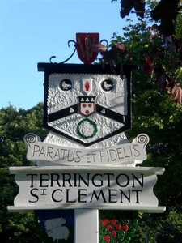
Clerk: K Treacher. Parish Office, The Pavilion, Churchgate Way, Terrington St Clement
Telephone: 01553 827499, E-mail:terringtonpc@outlook.com, Mobile: 07984352050

TO ALL ELECTORS
OF
TERRINGTON ST CLEMENT
THE ANNUAL
PARISH ASSEMBLY
WILL BE HELD
ON
MONDAY 23 APRIL 2018
COMMENCING AT 7.30 P.M.
IN THE PAVILION CHURCHGATE WAY
With Chairman of the Council Councillor in the Chair
Agenda
- Apologies for Absence and reasons given
- Read and confirm the Minutes of the 2017 Parish Meeting
- Matters Arising from the Minutes
- Chairman’s Report on activities of the Parish Council during the past year.
- Receive the accounts of the Charity Trustees
- Receive accounts of the Fuel Charity and A.B. Cave Fund
- Receive Statement of the Audited Parish Council Accounts
- Discuss Parish Matters and, if necessary, pass resolutions thereon
ALL ELECTORS ARE WELCOME TO ATTEND.

