TERRINGTON ST CLEMENT PARISH COUNCIL 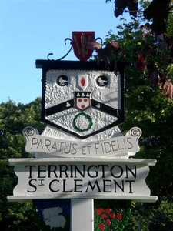

Clerk: K Trekacher. Parish Office, The Pavilion, Churchgate Way, Terrington St Clement

Telephone: 01553 827499, E-mail:terringtonpc@outlook.com

**Dear Councillor,**

**You are hereby summoned to attend an Ordinary Meeting of the Terrington St Clement Parish Council**

**which will be held on Wednesday 20 JULY 2022 commencing at 7.45 p.m. in the Pavilion, Churchgate Way, Terrington St Clement.**

**Prior to the commencement of the meeting a 10 Minute Open Forum will be held.**

**Signature:  K. Treacher. Clerk to the Council Date:** **14.07.2022**

**AGENDA**

1. To receive apologies and reasons given.
2. Declarations of Interest for the agenda items and written requests for Dispensations for DPI’s and

grants of requests as appropriate

1. To resolve e to approve the minutes of the meetings held on 15 June 2022
2. Clerks Report
3. Chairman’s Report
4. Financial Matters

a) To resolve to approve the Invoices for payment and Bank Reconciliation as per the Financial

Report as recommended by the Finance Committee

b) To resolve to consider quote for CCTV system for Benn’s Lane Play Area

c) To resolve to consider donation to NARS

d) To resolve to consider quote for Playground Signs for Benn’s Lane Play Area

7. To resolve to receive matters from parishioners at the Annual Assembly

8. Correspondence

**To receive general correspondence as per the Distribution List e-mailed to all Cllrs prior to the**

**Meeting**

1. **Village Hall Committee** – Request for Grant Supporting Letter and Complaint.
2. **Resident** – Speed Watch
3. **NCC –** Rangers Visit
4. **Citizens Advice –** Thank you letter
5. **E.A.C.H** – Thank you letter
6. To resolve to receive updates of tasks outstanding:
7. Update on sale of maintenance equipment
8. Update on Old School Project
9. Members Comments -To receive any comments from members of the council and requests for matters to be placed on the next agenda. No resolutions may be passed under this item.
10. **To resolve to go into closed session if required in accordance with the Public Bodies (admissions to meetings) Act 1960. Should this resolution be passed the public and press will be required to leave the meeting at this stage.**