TERRINGTON ST CLEMENT PARISH COUNCIL 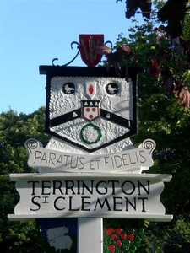

Clerk: K Treacher. Parish Office, The Pavilion, Churchgate Way, Terrington St Clement, PE34 4PG

Telephone: 01553 827499, E-mail:terringtonpc@outlook.com,

**Dear Councillor,**

**You are hereby summoned to attend a meeting of the Planning Committee to be held on WEDNESDAY 15 FEBRUARY 2023 commencing at 7.20 P.M. in the Community Room, The Pavilion, Churchgate Way, Terrington St Clement.**

**Signed: **

**K. Treacher. Clerk to the Council Date: 07.02.23**

**A 10 Minute Open Forum will be held to allow members of the public to speak with regards to Agenda items before the Meeting commences.**

**Other applications may be considered at the meeting if they are received after the Agenda is issued.**

**AGENDA**

1. Apologies for Absence and reasons given
2. To resolve to declare any Interests or DPIs
3. To resolve to approve the minutes of the meeting held on 18 January 2023

4. To resolve to consider planning applications received.

|  |  |
| --- | --- |
| **APPLICATION NO:** | **DETAILS** |
| 23/00127/F | To replace a single story 'Utility Room' on the North side of 113 Haygreen Road with a single story wrap around extension on the north and east of the property. The new build would form an extension to the existing kitchen, a new utility area and a ground floor bedroom with bathroom. at Nelson House 113 Hay Green Road South Terrington St Clement King's Lynn Norfolk PE34 4PU |
| 23/00074/F | Proposed Rear Extension And Proposed First Floor Extension To Create A Chalet Bungalow at The Bungalow 31 Market Lane Terrington St Clement King's Lynn Norfolk PE34 4HR |
| ROAD NAME CONSULTATION | Proposal to change road name to 77 and 79 Station Road TSC to Smartlift Road |