TERRINGTON ST CLEMENT PARISH COUNCIL 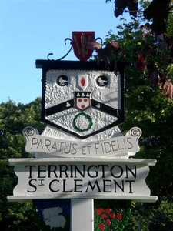
Clerk: K Treacher. Parish Office, The Pavilion, Churchgate Way, Terrington St Clement, PE34 4PG
Telephone: 01553 827499, E-mail:terringtonpc@outlook.com,

Dear Councillor,
You are hereby summoned to attend a meeting of the Planning Committee to be held on WEDNESDAY 21 JUNE 2023 commencing at 7.20 P.M. in the Community Room, The Pavilion, Churchgate Way, Terrington St Clement.

AGENDA

- Apologies for Absence and reasons given
- To resolve to declare any Interests or DPIs
- To resolve to approve the minutes of the meeting held on 15 March 2023
4. To resolve to consider planning applications received.

APPLICATION NO: | DETAILS
23/00893/F | Retention of existing front timber fence and gates at Willowshade 56 Lynn Road Terrington St Clement King's Lynn Norfolk PE34 4JX
23/00357/F (Amended) | Proposed double storey extension and outbuilding to garden at 2 Tower Road Terrington St Clement King's Lynn Norfolk PE34 4LP
23/00471/F | Conversion of the existing agricultural barn into dwelling house (C3). Proposed extension to existing barn. Proposed cart shed style garage. Change of use from agricultural land to residential garden at Barn At Land NE of Four Winds And Marlian And W of 112A Jankin Lane Jankin Lane Terrington St Clement Norfolk
23/00935/F | Proposed two storey extension including render and cladding to remaining property and brick surrounding to chimney stack/plinth. at 16 Moat Road Terrington St Clement King's Lynn Norfolk PE34 4PN
23/00730/F | Two storey side extension and alterations to dwelling at 43 Northgate Way Terrington St Clement King's Lynn Norfolk PE34 4LD
23/00843/F | Extension to Detached Garage. at Rothyar House 5 Eastgate Lane Terrington St Clement Norfolk PE34 4NU
23/00669/F | Addition of conservatory lobby to front of detached bungalow at Jan-Nor 3 Church Bank Terrington St Clement King's Lynn Norfolk

