TERRINGTON ST CLEMENT PARISH COUNCIL 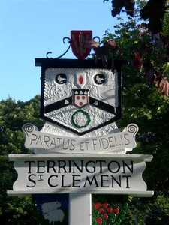

Clerk: K Treacher. Parish Office, The Pavilion, Churchgate Way, Terrington St Clement

Telephone: 01553 827499, E-mail:terringtonpc@outlook.com

**Dear Councillor,**

**You are hereby summoned to attend an Ordinary Meeting of the Terrington St Clement Parish Council**

**which will be held on Wednesday 21 JUNE 2023 commencing at 7.45 p.m. in the Pavilion, Churchgate Way, Terrington St Clement.**

**Prior to the commencement of the meeting a 10 Minute Open Forum will be held.**

**Signature:  K. Treacher. Clerk to the Council Date:** **15.06.23**

**AGENDA**

1. To receive apologies and reasons given.
2. Declarations of Interest for the agenda items and written requests for Dispensations for DPI’s and

grants of requests as appropriate

1. To resolve to approve the minutes of the meeting held on 15 March 2023
2. Clerks Report
3. Chairman’s Report
4. Financial Matters

a) To resolve to approve the Invoices for payment and Bank Reconciliation as per the Financial

Report as recommended by the Finance Committee

b) To resolve to Approve the Annual Return for the Year Ending 31 March 2017.

i)Annual Governance Statement

ii)Statement of Accounts

iii) Effectiveness of the Internal Audit

c) To resolve to approve to appoint a surveyor to provide a report of the repair works required for the

pavilion.

1. Correspondence
2. **To receive general correspondence as per the Distribution List e-mailed to all Cllrs prior to the**

**Meeting**

1. To resolve to consider the conversion of the Tractor Shed to a Men’s Shed or a Parish Council Office
2. To resolve to confirm a date for the Memorial Field Meeting.
3. To resolve to receive updates of tasks outstanding:
4. Update on Old School Project
5. Update on Tennis Club Lease
6. Members Comments -To receive any comments from members of the council and requests for matters to be placed on the next agenda. No resolutions may be passed under this item.
7. **To resolve to go into closed session if required in accordance with the Public Bodies (admissions to meetings) Act 1960. Should this resolution be passed the public and press will be required to leave the meeting at this stage.**