TERRINGTON ST CLEMENT PARISH COUNCIL 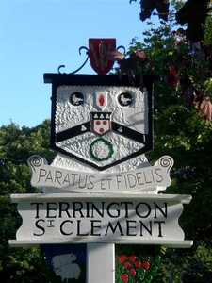

Clerk: K Treacher. Parish Office, The Pavilion, Churchgate Way, Terrington St Clement

Telephone: 01553 827499, E-mail:terringtonpc@outlook.com

**Dear Councillor,**

**You are hereby summoned to attend an Ordinary Meeting of the Terrington St Clement Parish Council**

**which will be held on Wednesday 21 FEBRUARY 2024 commencing at 7.45 p.m. in the Pavilion, Churchgate Way, Terrington St Clement.**

**Prior to the commencement of the meeting a 10 Minute Open Forum will be held.**

**Signature:  K. Treacher. Clerk to the Council Date:** **15.02.24**

**AGENDA**

1. To receive apologies and reasons given.
2. Declarations of Interest for the agenda items and written requests for Dispensations for DPI’s and

grants of requests as appropriate

1. To resolve to approve the minutes of the meeting held on 17 January 2024
2. Clerks Report
3. Chairman’s Report
4. Financial Matters

a) To resolve to approve the Invoices for payment and Bank Reconciliation as per the Financial

Report as recommended by the Finance Committee

1. Correspondence
2. **To receive general correspondence as per the Distribution List e-mailed to all Cllrs prior to the**

**Meeting**

**Norfolk C C –** Feasibility Study

1. To resolve to consider proposal for new parish council office in existing parish council buildings
2. To resolve to receive updates of tasks outstanding:
3. Update on Old School Project
4. Men’s Shed.
5. Pavilion Repairs
6. Members Comments -To receive any comments from members of the council and requests for matters to be placed on the next agenda. No resolutions may be passed under this item.
7. **To resolve to go into closed session if required in accordance with the Public Bodies (admissions to meetings) Act 1960. Should this resolution be passed the public and press will be required to leave the meeting at this stage.**

**NB: A representative from BCKLWN will be attending to speak in the open forum in relation to BCKLWN climate change initiatives**