TERRINGTON ST CLEMENT PARISH COUNCIL 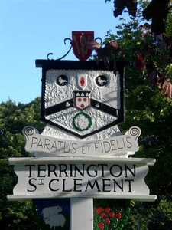

Clerk: K Treacher. Parish Office, The Pavilion, Churchgate Way, Terrington St Clement, PE34 4PG

Telephone: 01553 827499, E-mail:terringtonpc@outlook.com,

**Dear Councillor,**

**You are hereby summoned to attend a meeting of the Planning Committee to be held on WEDNESDAY 17 APRIL 2024 commencing at 7.20 P.M. in the Community Room, The Pavilion, Churchgate Way, Terrington St Clement.**

**Prior to the commencement of the meeting a 10 Minute Open Forum will be held.**

**Signature:  K. Treacher. Clerk to the Council Date: 11.04.24**

**AGENDA**

1. Apologies for Absence and reasons given
2. To resolve to declare any Interests or DPIs
3. To resolve to approve the minutes of 20 March 2024

4. To resolve to consider planning applications received.

|  |  |
| --- | --- |
| **APPLICATION NO:** | **DETAILS** |
| 24/00352/F | First floor extension and addition of car-port to rear of detached dwelling. at 43 Churchgate Way Terrington St Clement King's Lynn Norfolk PE34 4LZ |
| 24/00148/F | Proposed tractor store and concrete pad to replace existing buildings, new access, hardcore area and earth bund and screen planting. at Land And Buildings At N of Clear View Long Road Terrington St Clement Norfolk |
| 24/00506/F | Variation of condition numbers 2, 7 and 11 attached to planning permission 22/00945/F: Conversion and change of use of detached Barn structure to a Residential Dwelling. at Church Farm House 100 Churchgate Way Terrington St Clement KINGS LYNN Norfolk PE34 4LZ |

Additional applications received may be considered if received after this date.